          

**GAS - OIL - FUEL**

**GAS - OIL - FUEL**



Image result for ESSOImage result for ESSOImage result for ESSOImage result for ESSOImage result for ESSOImage result for ESSOImage result for ESSOImage result for ESSOImage result for ESSOImage result for ESSOImage result for ESSOImage result for ESSOImage result for ESSOImage result for ESSO

GAS - OIL - FUEL

C:\Users\joeia\AppData\Local\Microsoft\Windows\INetCache\Content.MSO\D862A8EA.tmp  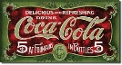     

 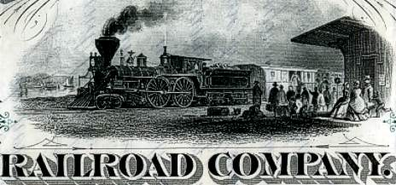  

           

**GAS - OIL - FUEL**

**GAS - OIL - FUEL**

Image result for ESSOImage result for ESSOImage result for ESSOImage result for ESSOImage result for ESSOImage result for ESSOImage result for ESSOImage result for ESSOImage result for ESSOImage result for ESSOImage result for ESSOImage result for ESSOImage result for ESSOImage result for ESSO

GAS - OIL - FUEL

C:\Users\joeia\AppData\Local\Microsoft\Windows\INetCache\Content.MSO\D862A8EA.tmp       

   

           

**GAS - OIL - FUEL**

GAS - OIL - FUEL

**GAS - OIL - FUEL**

Image result for ESSOImage result for ESSOImage result for ESSOImage result for ESSOImage result for ESSOImage result for ESSOImage result for ESSOImage result for ESSOImage result for ESSOImage result for ESSOImage result for ESSOImage result for ESSOImage result for ESSOImage result for ESSO

GAS - OIL - FUEL

C:\Users\joeia\AppData\Local\Microsoft\Windows\INetCache\Content.MSO\D862A8EA.tmp       

   

GAS - OIL - FUEL

GAS - OIL - FUEL